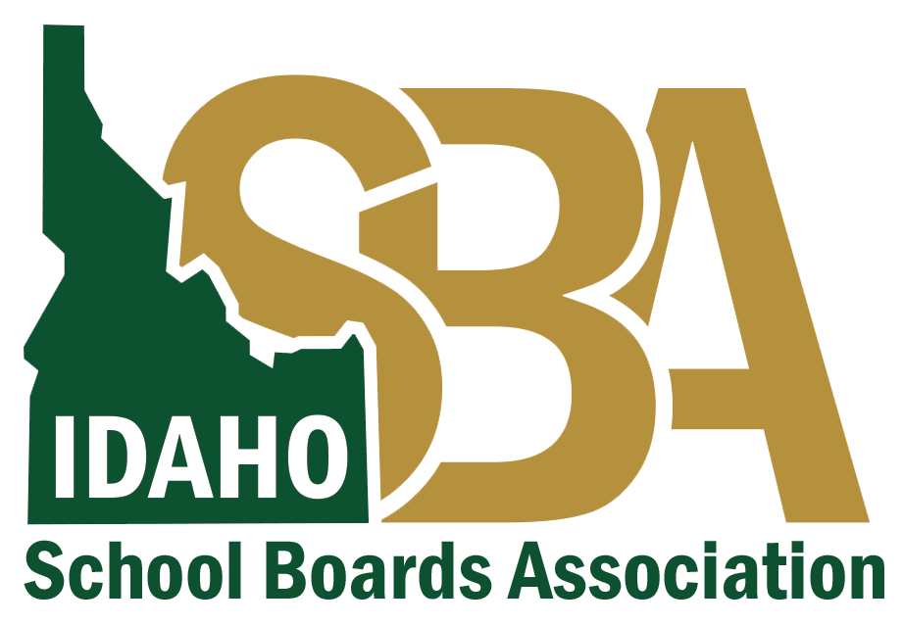
Best Practices for COVID-Related Communication
Before communication goes out, ensure it is consistent with your local health district guidance.
If you need assistance finalizing talking points, please contact:
Karen Echeverria, ISBA Executive Director, at karen@idsba.org or 208.890.6506 or
Quinn Perry, Policy & Government Affairs Director, at quinn@idsba.org or 208.407.8644

- Always emphasize the safety and health of students, staff, and community.
- Contact your local health district for guidance about what you should do to ensure students and staff are safe. Include their guidance in the communication whenever possible. If you can build a relationship with them in advance, it will help when you must address an urgent issue.
- Stay informed about local, state and federal health recommendations, and be attentive to the number of COVID-19 cases in your community and the state.
- Encourage all audiences to continue to follow CDC guidelines to protect themselves, including frequent handwashing, staying home when sick, physical distancing in public, and wearing a cloth mask when social distancing is not possible.
- Protect the identity of the individual(s) involved in the situation.
- Use language that is honest, but also calming and reassuring.
- Ensure parents and community members know you will communicate with them frequently and transparently so they can make the best health-related decisions for their families.
- Verify whether the person who tested positive or was exposed has been in contact with students or staff or has been on school grounds during the incubation period of 14 days. It is important to clarify whether this was the case in your communication.
- If it is necessary to reschedule or postpone an event, explain to parents and the community when they will receive an update from the school or district. If you have established a back-up plan, communicate the details of the plan.
- Acknowledge the disappointment students will feel if events and programs are interrupted because of a COVID-19 risk. Empathy is important.
- Communicate with those most directly impacted first, followed by staff, parents and students, and then the general public.
- Consider using a phone message or video to provide a more personal touch to announcements, especially if the news may be emotional or concerning for families.
- Call or email the ISBA Team anytime you have a question or need assistance with messaging.
When communicating with employees, students, and families about COVID-19, here are a few helpful key messages and tips to keep in mind.
- The health and safety of students and employees is the top priority.
- Schools should work closely with public health officials and rely heavily on their guidance because they are the experts.
- Local and state health departments are the best resources for current information about the novel coronavirus.
- Emphasize what is known at the time of the communication.
- Include the date/time in all communications, including social media posts, because information can change quickly.
- Include best hygiene practices in communications.
- Create a web page that can be easily updated with links to the most current information from reliable sources, including the local and state health departments and the Centers for Disease Control. The best way to combat rumors and speculation is easy access to reliable information.

