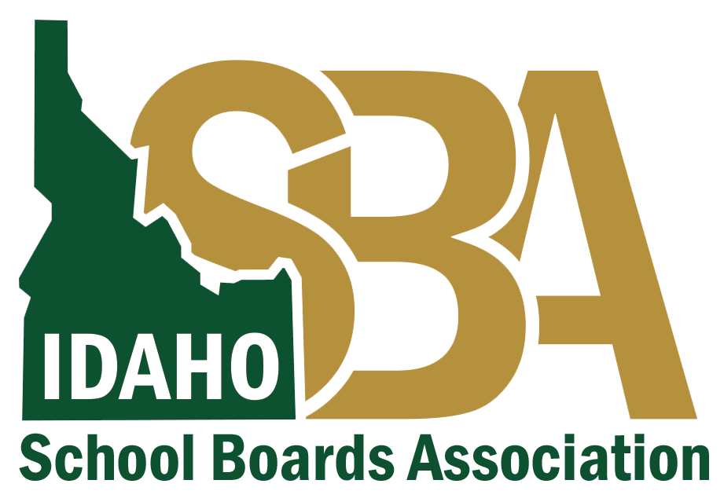
Media Press Release
Before this communication goes out, ensure it is consistent with your local health district guidance.
If you need assistance finalizing this press release, please contact
Karen Echeverria, ISBA Executive Director, at karen@idsba.org or 208.890.6506 or
Quinn Perry, Policy & Government Affairs Director, at quinn@idsba.org or 208.407.8644

NEWS RELEASE
DATE, 2020
Media Contact:
Name, Email, Phone #
_____________ School District Responds to Positive COVID-19 Case(s)
The [________ School District] and [ ________ Health Department] partner in response to ensure safety of all students and staff members
(CITY, Idaho. - A [________School District employee / student at ________] School has tested positive for COVID-19.
We are working closely with ____________[INSERT local health department] to respond to this news and protect the health of our community.
Each situation calls for different protocols. In this case, we will follow the following steps:
1. (customize steps)
2.
We will post updates on the homepage of our website.

###

