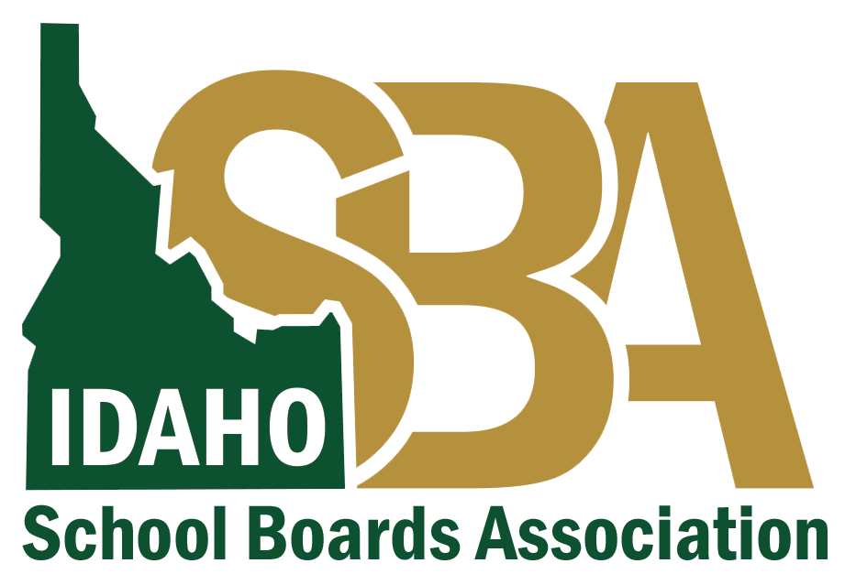
Phone Call (Pre-Recorded Message)
Before this communication goes out, ensure it is consistent with your local health district guidance.
If you need assistance finalizing your talking points, please contact
Karen Echeverria, ISBA Executive Director, at karen@idsba.org or 208.890.6506 or
Quinn Perry, Policy & Government Affairs Director, at quinn@idsba.org or 208.407.8644
This is Superintendent (name) from (name) school/school district.
Recently, we were notified that a school district employee / student has tested positive for COVID-19. If you have not been notified that your child was in direct contact with an exposed person, they can return to school.
We understand that this might raise concerns and questions about how this impacts your child and family as members of the school/school district community.
We are working closely with [local health department] to respond to this news and protect the health of our community by temporarily closing [school].
We have taken the following immediate action:
(list steps)
We care about the health and safety of our community.
For more information, visit the homepage of our website at ___________________.

