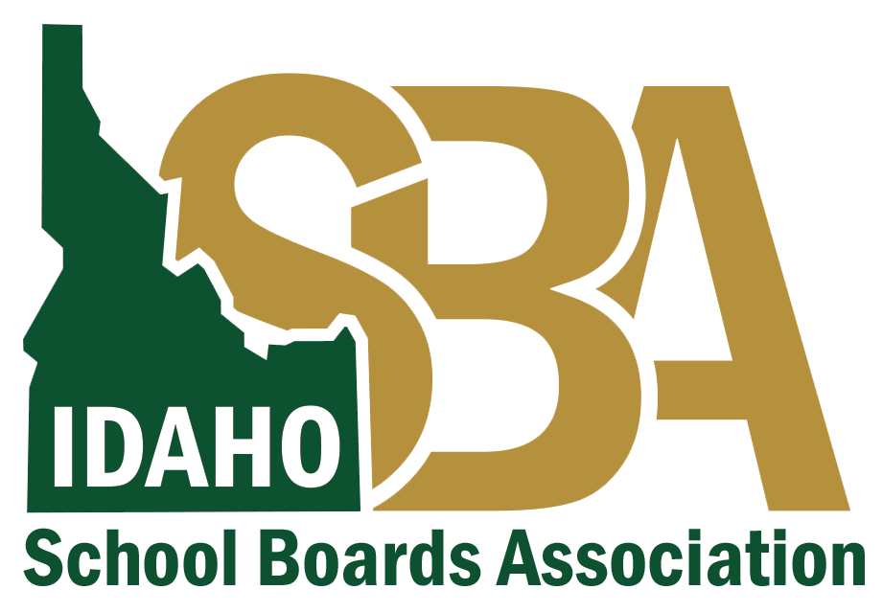
Script for Board Members, Teachers, and Staff - Positive Case at School
Before this communication goes out, ensure it is consistent with your local health district guidance.
If you need assistance finalizing these talking points, please contact
Karen Echeverria, ISBA Executive Director, at karen@idsba.org or 208.890.6506 or
Quinn Perry, Policy & Government Affairs Director, at quinn@idsba.org or 208.407.8644
A positive case of COVID-19 was reported today, (date).
This is difficult news and impacts all who are part of the (school / district) community.
While we are not able to share personally-identifiable information, we care about keeping our
community informed.
Here’s what we know about the COVID-19 case(s) reported:
● On [date], an employee / student at [District / School Name] notified us of their positive
test result for COVID-19.
● It has been ___ days since the employee / student was last in contact with staff or
students in our district.
● The individual(s) involved have been asked to stay home and self-isolate, as have any people who were in close contact with them.
● The safety and well-being of our staff and students is our top priority.
Our district has taken these action steps:
● They’ve contacted, and are working closely with, the local health district.
● They’ve contacted all person(s) who were in close contact with the individual.
● They’ve (closed/partially closed the school building) and launched deep cleaning efforts.
● They’ve notified all students and families.

